Robusticity is…

“activity performed daily for long periods of time, using either specific tools or gestures which result in a repeated combination of biomechanical loads (duration, frequency, force), will be reflected in the geometric characteristics of the bone and in the attachment of the muscles, tendons, and ligaments. This occurs because physical activity stimulates the remodeling of bone to secure an effective response and to maintain the stability of the musculoskeletal system.”

“when there is no pathology, morphological changes in the entheses (irregularities, crests, concavity, osseous deposits, etc.) are interpreted as robusticity”

“Entheses of slight robusticity have characteristics similar to those areas of the bone where there are no muscular insertions. Conversely, extremely robust entheses are very different from plain bone and their features are macroscopically very clear.”

Hawkey and Merbs 1995 is the original method of scoring entheseal change or musculoskeletal stress markers (terms are interchangeable in biological anthropology). It has 3 scoring systems, robusticity marker, stress lesions, and ossification exostosis.

Robusticity marker

“This category describes the normal reaction of the skeleton to habitual muscle usage and reflects daily activities that produce rugged markings at the musculoskeletal site of attachment.”

Stress lesions

“Histological evidence suggests further that prolonged and habitual tension can cause small muscle fibres to tear and reattach to the periosteum, disrupting the blood supply to the bone. If the disruption is severe and continuous, bone necrosis may occur.”

Ossification exostosis

“This particular type of MSM **is** due usually to an abrupt macro trauma, such as a muscle rupture that could result from a sudden fall on the ice. When a bone avulsion injury occurs, new bone formation may be incorporated into the ligament or muscle tissue, and result in a exostosis, or bony 'spur'.”

However, most anthropologists have suggested that when using the Hawkey and Merbs (1995) method only robusticity should be recorded. This became a consensus, so in the newer methods people only score robusticity and leave out the other two because of stress lesions and ossification exostosis being due to trauma, as Hawkey and Merbs say themselves. I am scoring all three for the qualitative method and running stats on them with and without the two others to see how they affect the stats, but I agree with the consensus. You see those two maybe 5% of the time, suggesting it has nothing to do with activity and is only trauma, so I had no intention of including them in the quantitative method.

These are bad photos that Hawkey and Merbs published, but here are the photos they include to show robusticity. They are essentially roughened bone that gets gradually worse.

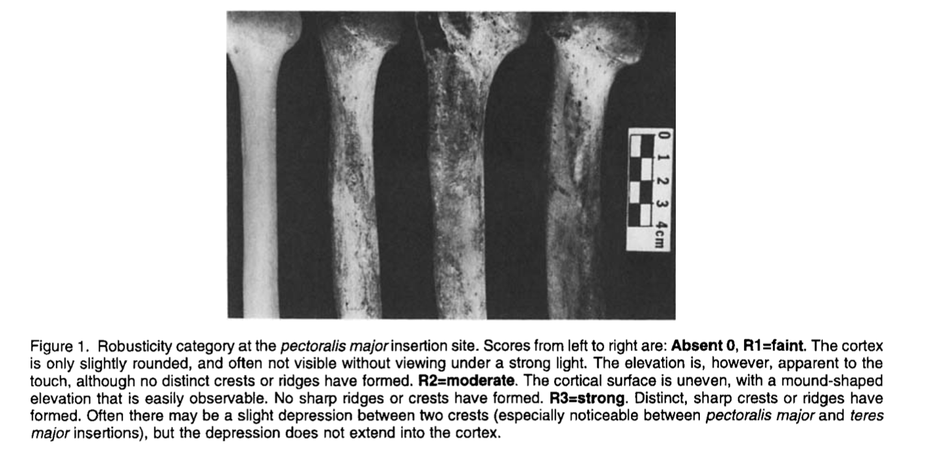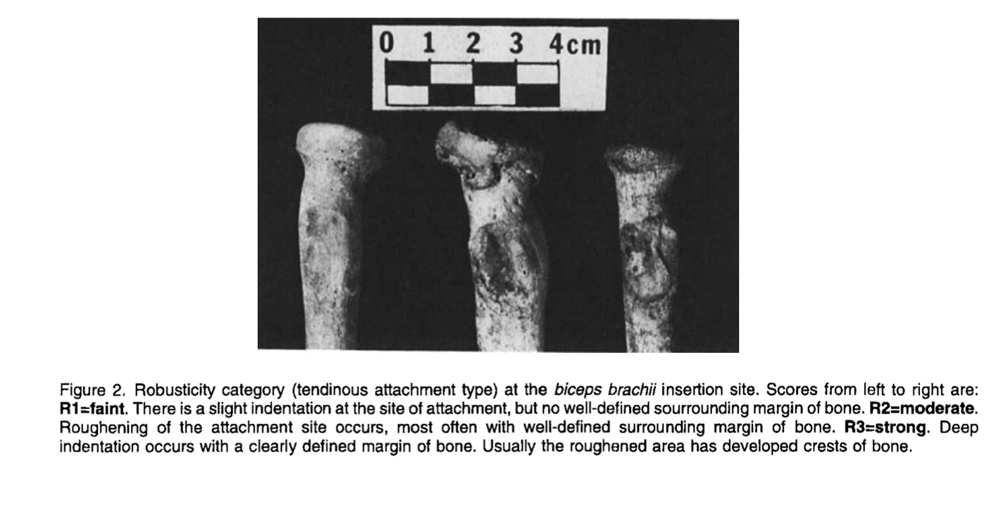

Here is an ossification exostosis (or also can be called osteophyte). When you have that you only see one large bone spur, similar to the one peak we saw in Dao’s tests. You don’t tend to see much robusticity around it, which is why the new methods have decided to not include ossification exostosis.

